NAME : Manasseh. M
Topic : Data Analyst

Task: Data Visualization and Insight Communication using R

1. INTRODUCTION
Data visualization is the process of representing data in graphical form so that trends, patterns, comparisons, and relationships can be understood easily. Instead of analyzing a large amount of raw data in the form of rows and columns, charts and graphs help present the information in a simple and meaningful way. Data visualization is useful for both technical and non-technical users because it makes complex information easier to understand and communicate.
This project focuses on Data Visualization and Insight Communication using R programming. The Titanic dataset was selected for this analysis because it contains both numerical and categorical variables. The dataset includes information about passengers such as their age, gender, passenger class, ticket fare, family information, port of embarkation, and survival status.
R programming and visualization libraries such as ggplot2 and dplyr were used to analyze and visualize the dataset. Before creating the graphs, the dataset was imported and examined using functions such as head(), str(), and summary(). Missing values were identified and handled to improve the quality of the data.

2. DATASET OVERVIEW
The Titanic dataset was used for this data visualization project. It contains information about the passengers who travelled on the Titanic, including their demographic details, travel information, and survival status. This dataset is suitable for visualization because it contains a combination of numerical and categorical variables that can be represented using different types of charts and graphs.
The dataset contains 891 records and 12 columns. Each row represents an individual passenger, while each column represents a specific characteristic of that passenger.
Dataset Name
Titanic Dataset
Number of Records
891
Number of Columns
12
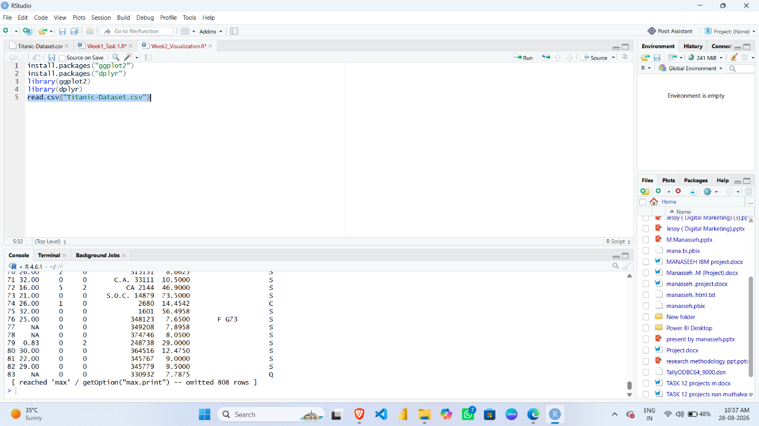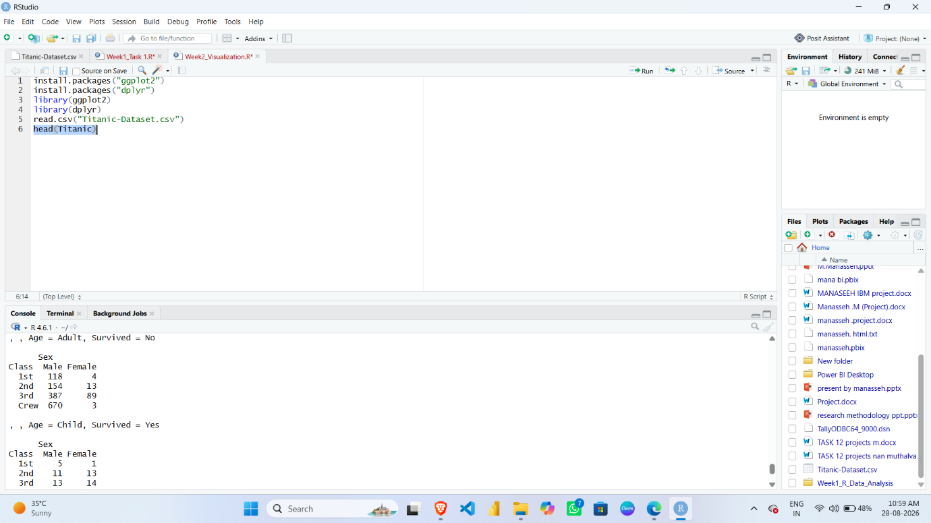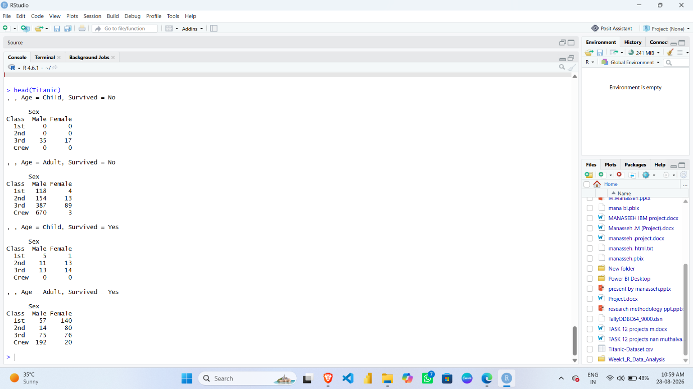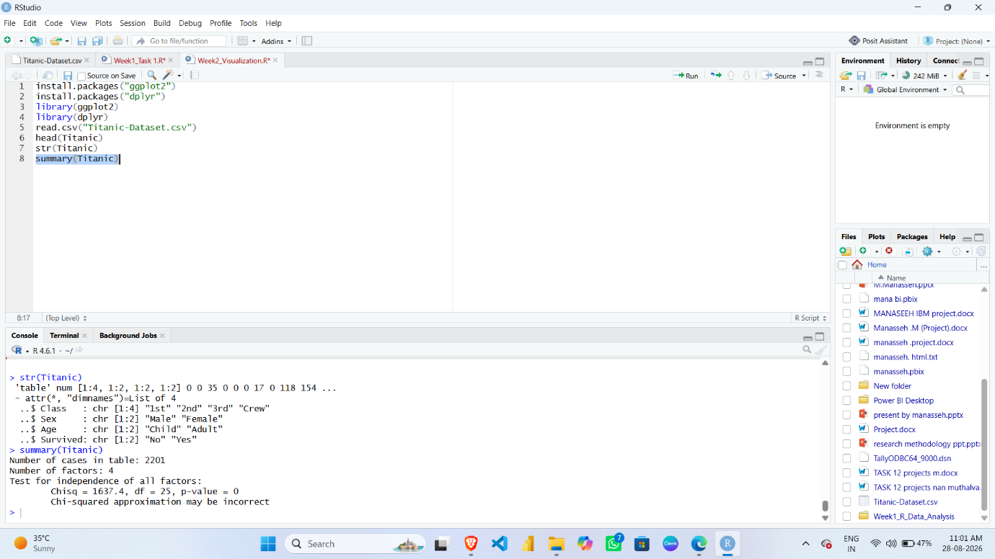

3. TOOLS USED
R Programming Language
R is a programming language used for statistical computing, data analysis, and data visualization. It was used to import, prepare, analyze, and visualize the Titanic dataset.
RStudio
RStudio is an integrated development environment used for writing and executing R programs. It was used to write the R code, run the analysis, and view the generated graphical outputs.
ggplot2
The ggplot2 library was used to create different types of high-quality visualizations. It was used for creating bar charts, histograms, scatter plots, box plots, and line charts.
dplyr
The dplyr library was used for data manipulation and analysis. Functions such as group_by() and summarise() were used to group the data and calculate survival rates for different categories.

4. DATA PREPARATION
Before creating visualizations, the Titanic dataset was prepared to ensure that the data used for analysis was meaningful and suitable for graphical representation. Data preparation is an important step because missing or incomplete values can affect the accuracy and interpretation of visualizations.
4.1 Missing Value Identification
The dataset was checked for missing values using the following R function:
colSums(is.na(titanic))
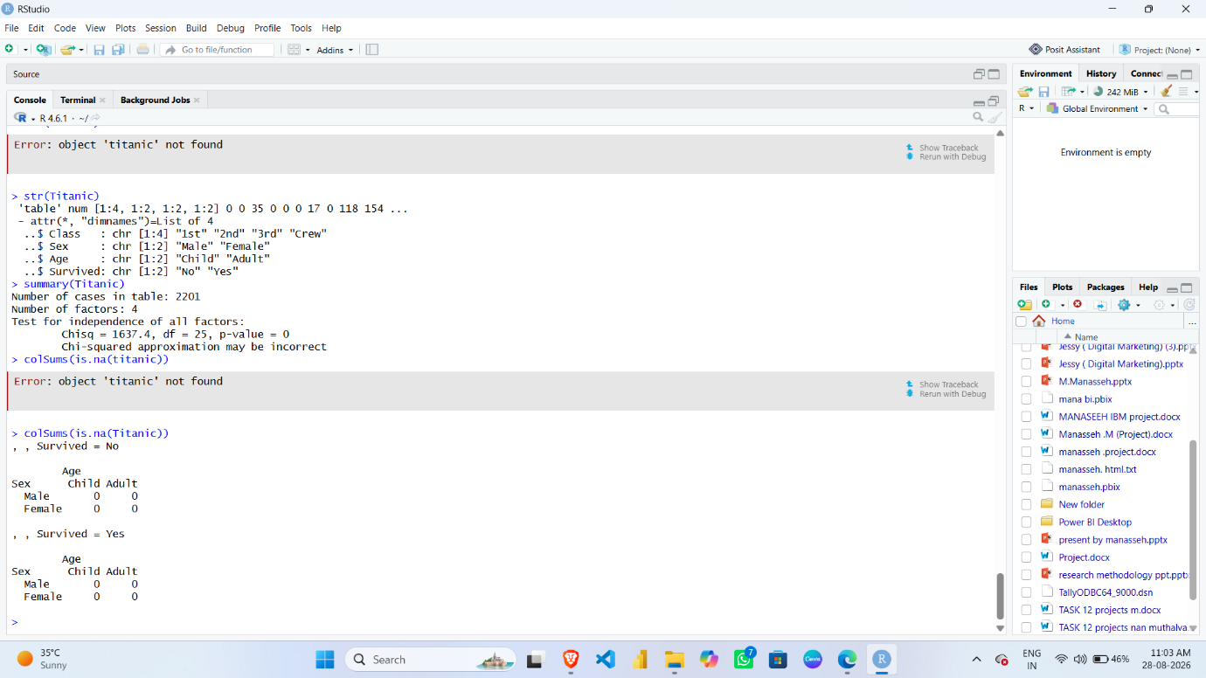

4.2 Handling Missing Values in Age
Age is a numerical variable. Some passenger age values were missing. Instead of removing the corresponding records, the missing values were replaced using the median age.
The median was selected because it is less affected by extreme values than the mean and provides a suitable central value for replacing missing numerical data.
The missing Age values were handled using the following R code:
titanic$Age[is.na(titanic$Age)] <- median(titanic$Age, na.rm = TRUE)
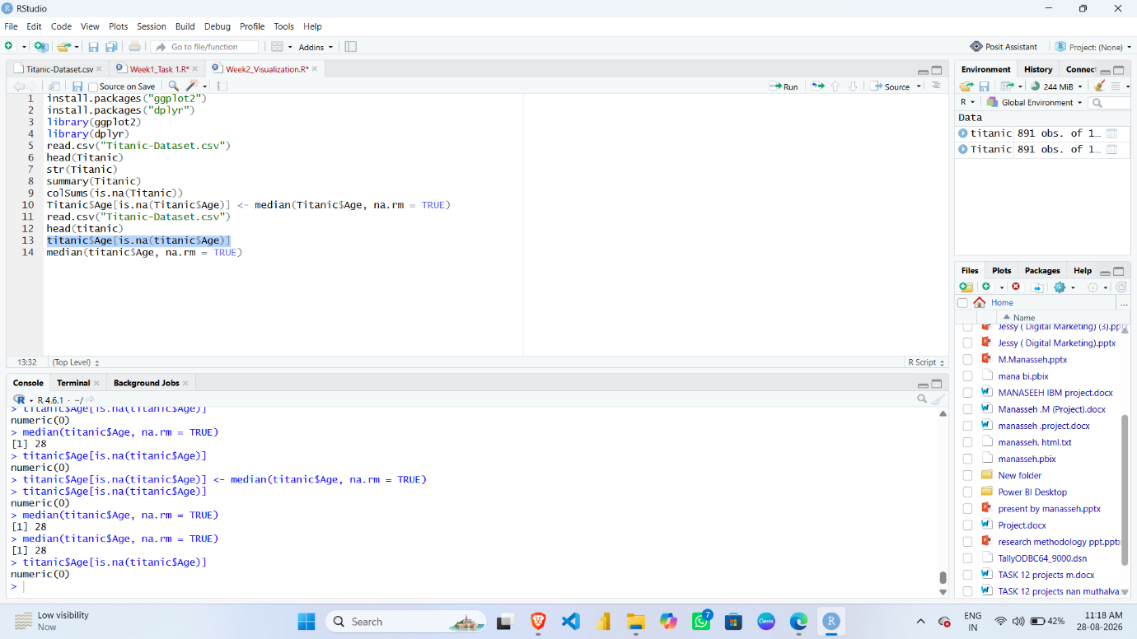

4.3 Handling Missing Values in Embarked
Embarked is a categorical variable that represents the port where a passenger boarded the ship. Missing values in this column were replaced using the mode, which is the most frequently occurring category.
The following code was used:
mode_embarked <- names(sort(table(titanic$Embarked), decreasing = TRUE))[1]
titanic$Embarked[is.na(titanic$Embarked)] <- mode_embarked
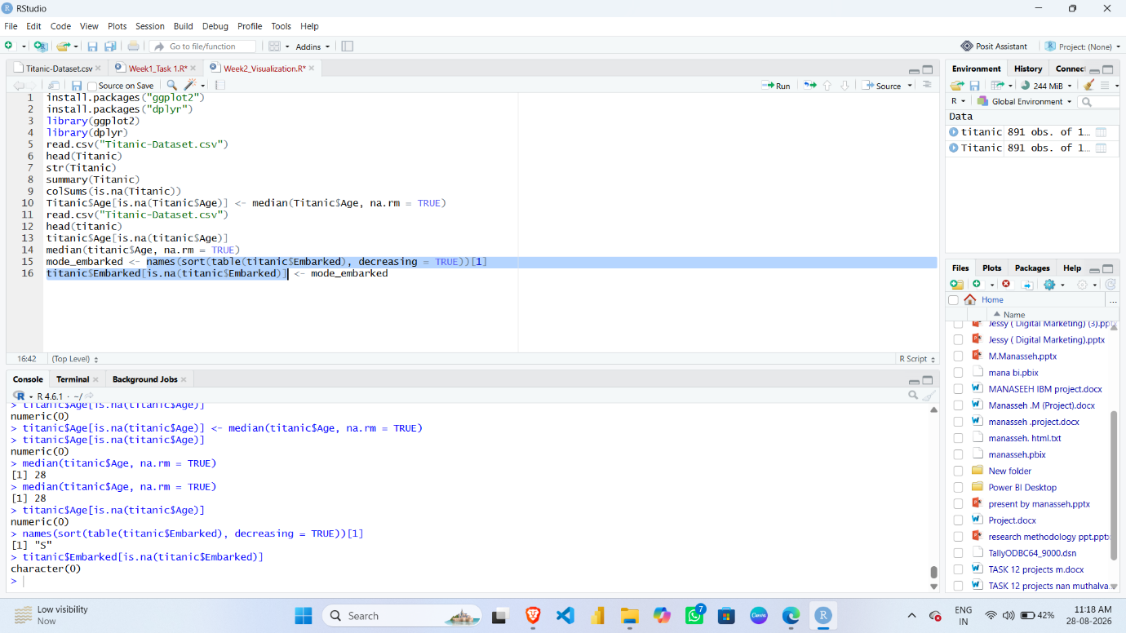

DATA VISUALIZATIONS

5.1 Survival Count

R Code
ggplot(titanic, aes(x = factor(Survived))) +
geom_bar() +
labs(
title = "Survival Count of Titanic Passengers",
x = "Survival Status",
y = "Number of Passengers"
)

Graph Screenshot
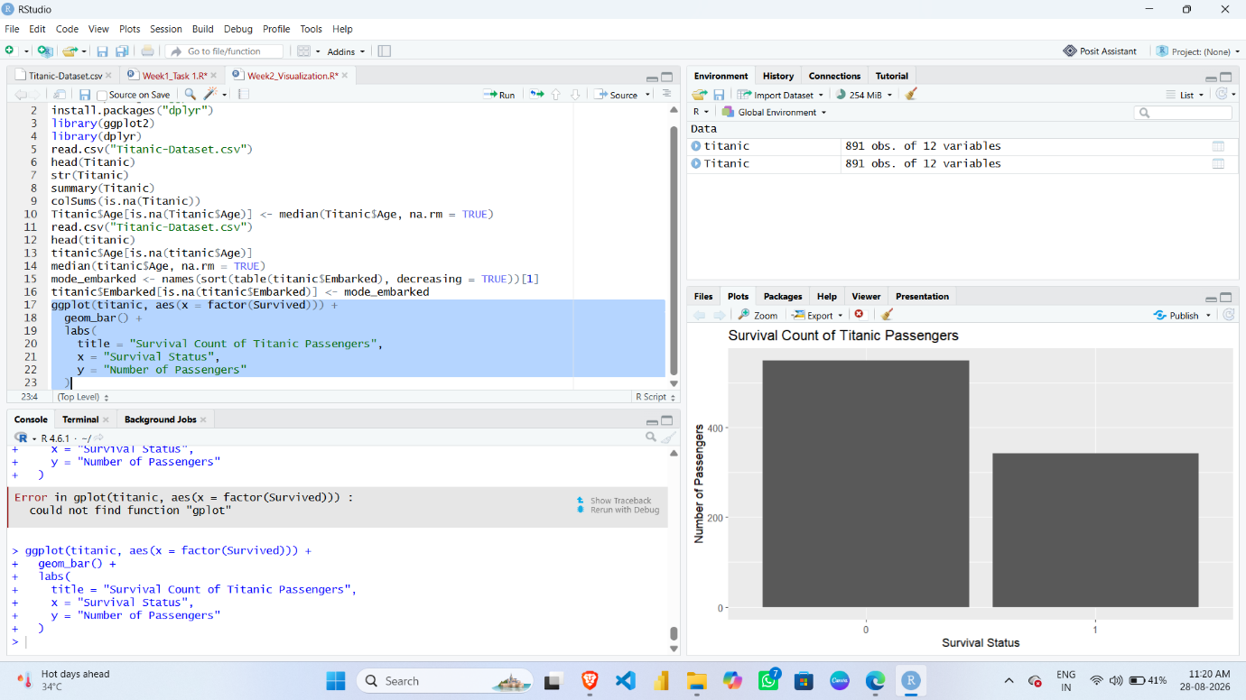

5.1 Survival Count
This bar chart shows the number of passengers who survived and the number of passengers who did not survive. The Survived variable contains two categories, where 0 represents passengers who did not survive and 1 represents passengers who survived.
A bar chart was selected because it is suitable for comparing the number of observations between different categories. The height of each bar represents the total number of passengers in that survival category.
The visualization shows that the number of passengers who did not survive was higher than the number of passengers who survived. This provides an initial understanding of the overall survival outcome of the Titanic passengers. The graph is simple and easy to understand, making it useful for communicating the basic survival distribution to a non-technical audience.

5.2 Survival by Gender

R Code
ggplot(titanic, aes(x = Sex, fill = factor(Survived))) +
geom_bar(position = "dodge") +
labs(
title = "Survival by Gender",
x = "Gender",
y = "Number of Passengers",
fill = "Survived"
)

Graph Screenshot
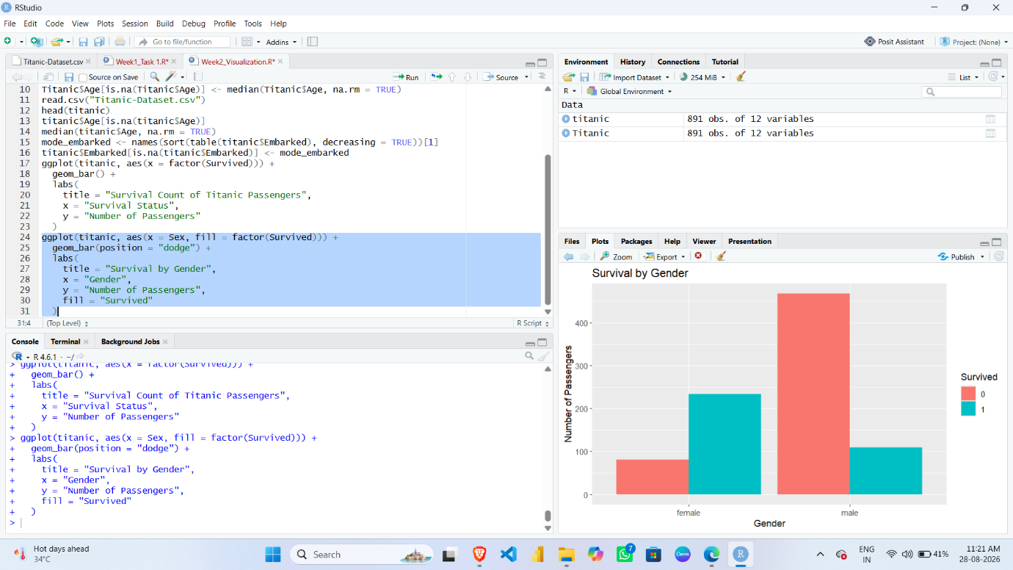

5.2 Survival by Gender
This visualization compares the survival status of male and female passengers. A grouped bar chart was used because it allows the survival and non-survival counts to be compared within each gender category.
The graph shows that survival patterns differed significantly between male and female passengers. The number of surviving female passengers was comparatively higher, while the number of male passengers who did not survive was higher.
This visualization is important because it demonstrates that gender was associated with different survival outcomes. The grouped bars make it easy to compare both survival categories and understand the difference between the two gender groups. This is one of the most useful visualizations for identifying demographic patterns in the dataset.

5.3 Number of Passengers by Class

R Code
ggplot(titanic, aes(x = factor(Pclass))) +
geom_bar() +
labs(
title = "Number of Passengers by Class",
x = "Passenger Class",
y = "Number of Passengers"
)

Graph Screenshot
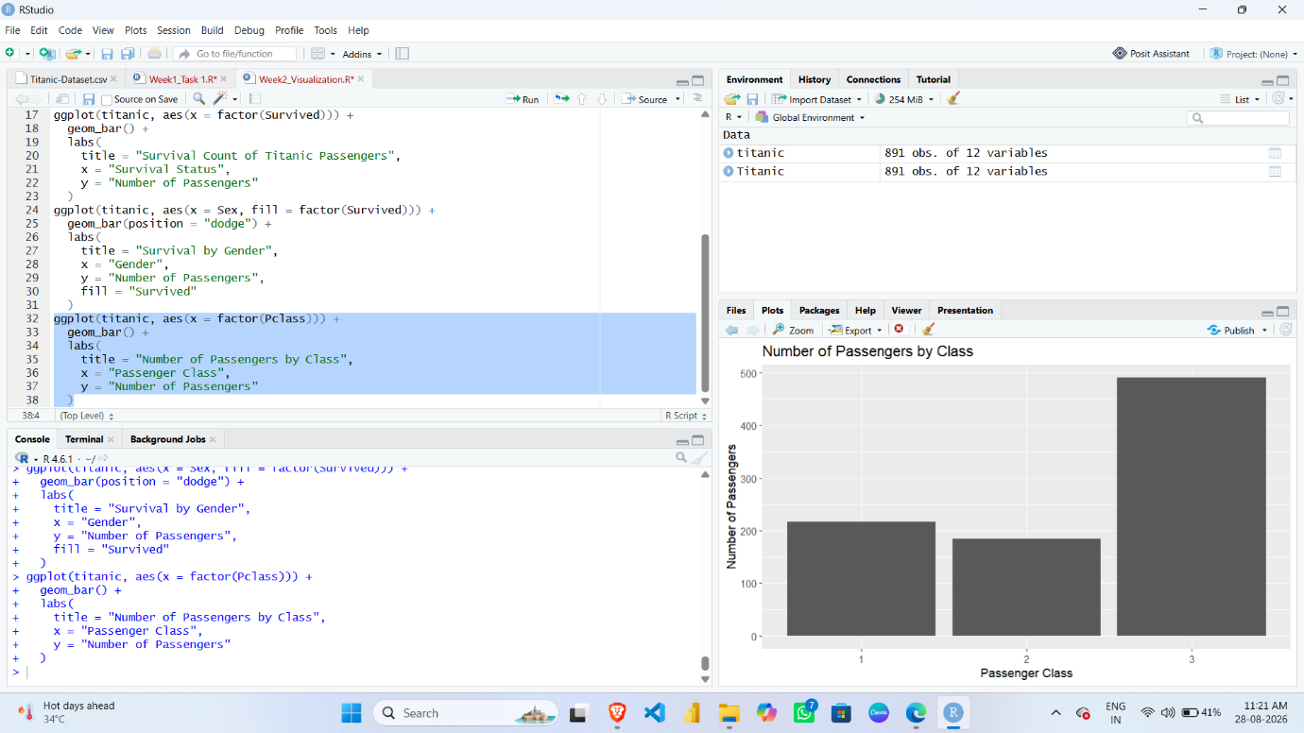

5.3 Number of Passengers by Class
This bar chart shows the number of passengers travelling in First Class, Second Class, and Third Class. Passenger Class is a categorical variable, so a bar chart is an appropriate visualization for comparing the number of passengers in each class.
The graph helps identify which passenger class contained the highest number of passengers. It also provides an understanding of how passengers were distributed across the three travel classes.
The visualization is useful because passenger class can be compared easily using the height of the bars. This information can also be used together with survival analysis to understand whether travel class was associated with different passenger outcomes.

5.4 Age Distribution

R Code
ggplot(titanic, aes(x = Age)) +
geom_histogram(bins = 30) +
labs(
title = "Age Distribution of Titanic Passengers",
x = "Age",
y = "Number of Passengers"
)

Graph Screenshot
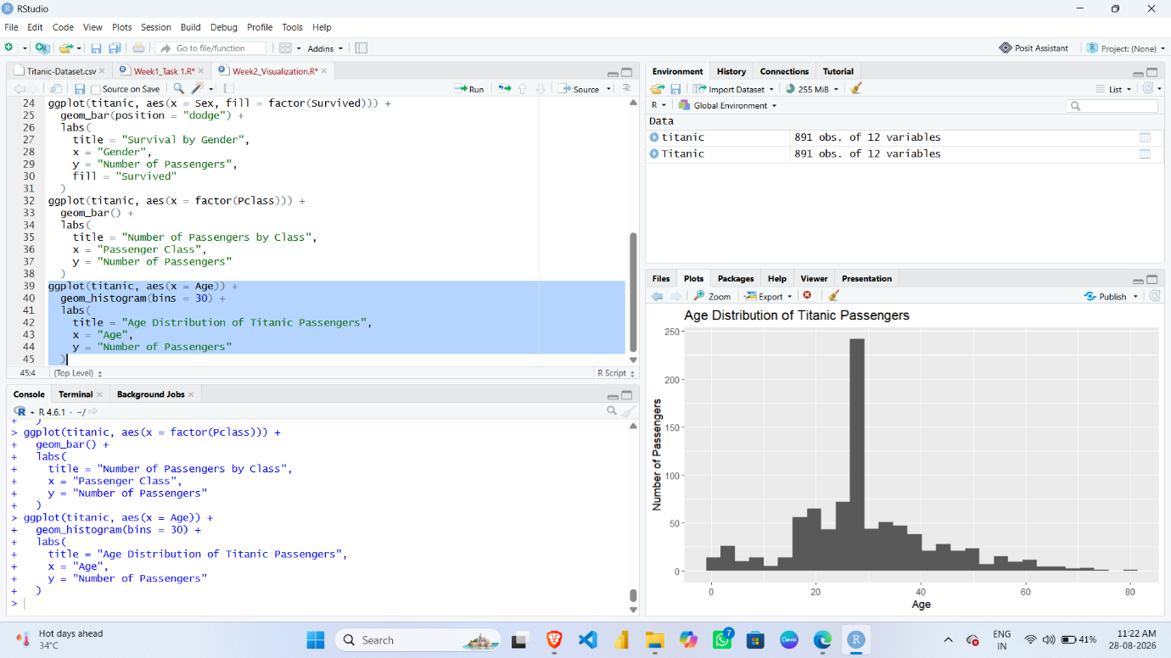

5.4 Age Distribution
This histogram shows the distribution of passenger ages. Age is a numerical variable, and a histogram is useful for understanding how numerical values are distributed across different ranges.
The graph shows the number of passengers within different age intervals. It helps identify the age groups that contained more passengers and provides an overview of the overall age pattern in the dataset.
The histogram can also help identify whether the data is concentrated around specific age ranges and whether the distribution contains extreme or unusual age values. This visualization provides a clear understanding of the demographic structure of the passengers and is useful for further analysis of age-related survival patterns.

5.5 Fare Distribution

R Code
ggplot(titanic, aes(x = Fare)) +
geom_histogram(bins = 30) +
labs(
title = "Fare Distribution of Titanic Passengers",
x = "Fare",
y = "Number of Passengers"
)

Graph Screenshot
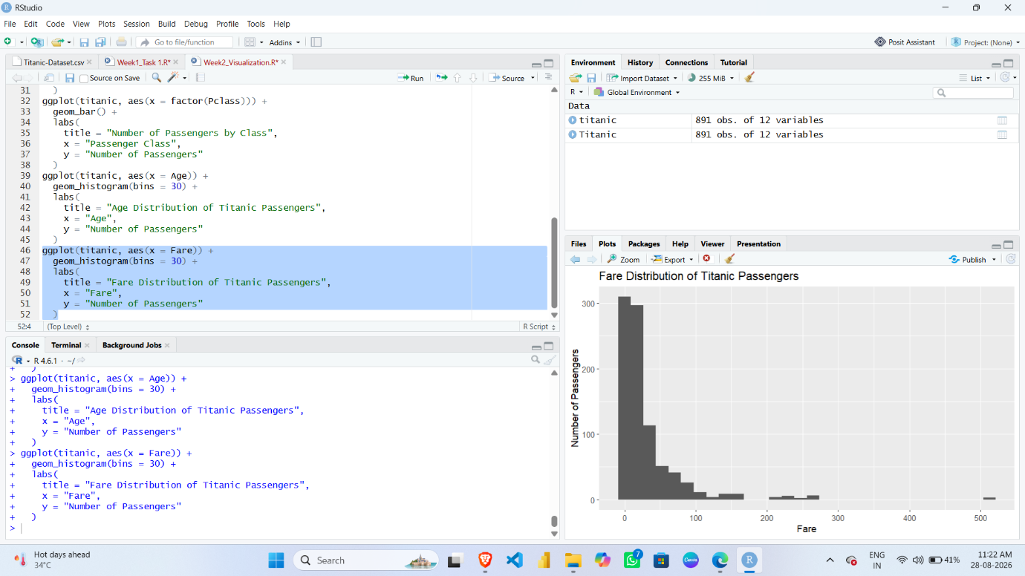

5.5 Fare Distribution
This histogram represents the distribution of ticket fares paid by Titanic passengers. Fare is a numerical variable, and a histogram was selected to understand how ticket prices were distributed.
The visualization shows that fares were not evenly distributed among passengers. Most observations were concentrated within lower fare ranges, while a smaller number of passengers paid comparatively higher fares.
This pattern indicates variation in ticket prices and may be related to factors such as passenger class. The histogram also helps identify unusually high fare values. Therefore, this visualization is useful for understanding the distribution and spread of passenger ticket fares.

5.6 Relationship Between Age and Fare

R Code
ggplot(titanic, aes(x = Age, y = Fare)) +
geom_point() +
labs(
title = "Relationship Between Age and Fare",
x = "Age",
y = "Fare"
)

Graph Screenshot
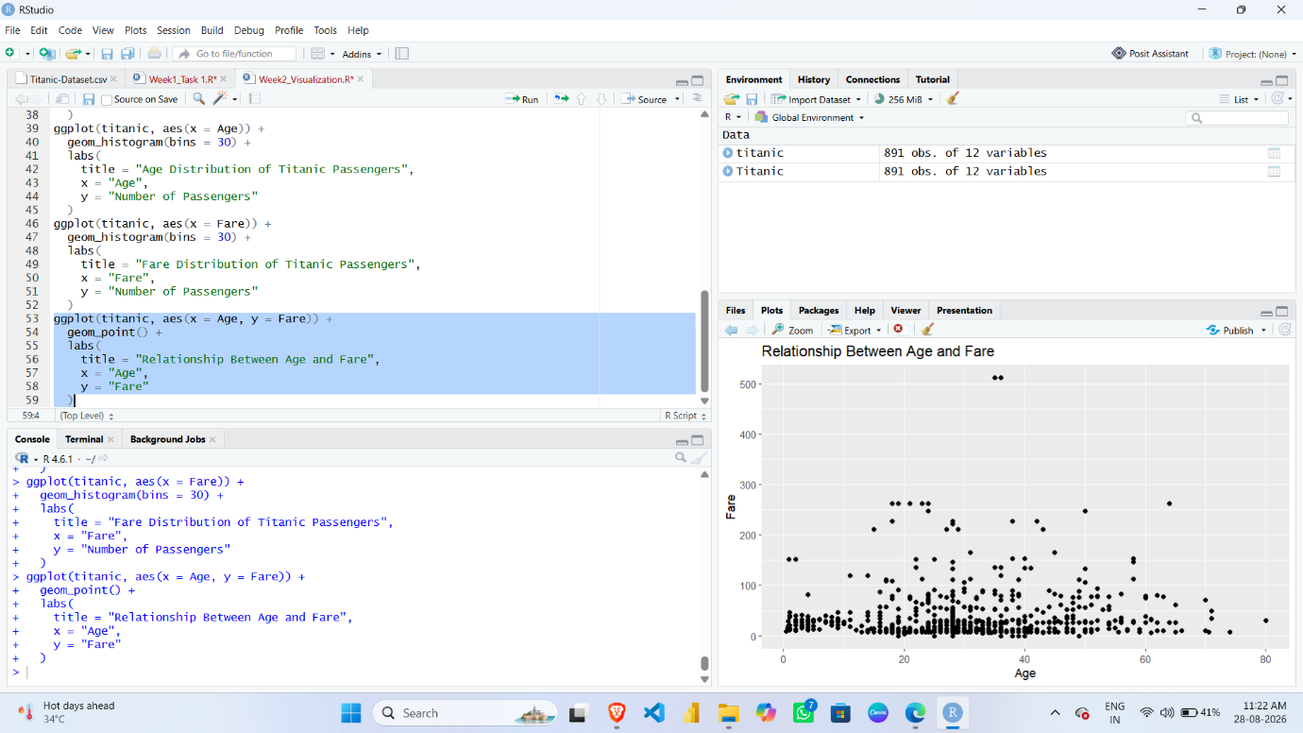

5.6 Relationship Between Age and Fare
This scatter plot examines the relationship between passenger age and ticket fare. Both Age and Fare are numerical variables, making a scatter plot suitable for studying their relationship.
Each point in the graph represents an individual passenger. The position of a point indicates the passenger's age and the fare paid.
The graph helps identify whether there is a clear positive or negative relationship between Age and Fare. It also helps identify clusters of observations and unusual values. The visualization indicates that ticket fare is influenced by factors other than age alone, as passengers of similar ages may have paid very different fares.
This graph is useful for identifying patterns and possible anomalies between two numerical variables.

5.7 Fare Distribution by Passenger Class

R Code
ggplot(titanic, aes(x = factor(Pclass), y = Fare)) +
geom_boxplot() +
labs(
title = "Fare Distribution by Passenger Class",
x = "Passenger Class",
y = "Fare"
)

Graph Screenshot

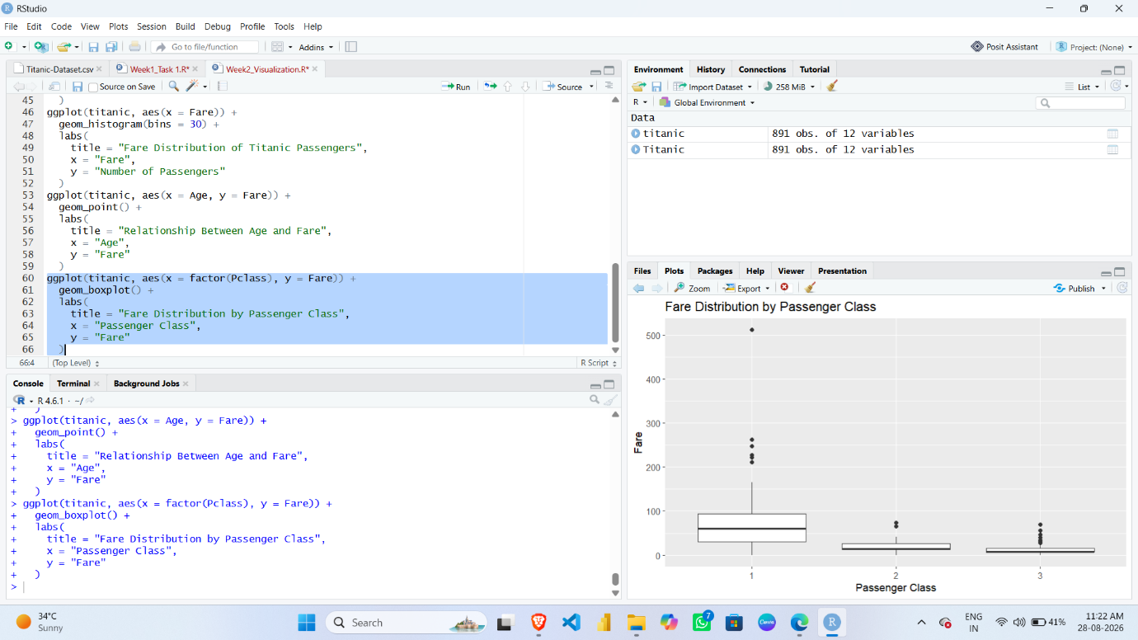

5.7 Fare Distribution by Passenger Class
This box plot compares the distribution of ticket fares across the three passenger classes. A box plot was selected because it clearly displays the median, spread, range, and possible outliers of numerical data.
The graph makes it possible to compare how ticket fares differed between First Class, Second Class, and Third Class passengers. The median fare and the spread of fares can be observed for each passenger class.
The presence of points outside the main box and whiskers indicates possible outliers. This visualization clearly demonstrates differences in ticket fare patterns between passenger classes and helps communicate the variation in fare values.

5.8 Survival Rate by Passenger Class

R Code
class_survival <- titanic %>%
group_by(Pclass) %>%
summarise(
Survival_Rate = mean(Survived) * 100
)

ggplot(class_survival, aes(x = factor(Pclass), y = Survival_Rate)) +
geom_bar(stat = "identity") +
labs(
title = "Survival Rate by Passenger Class",
x = "Passenger Class",
y = "Survival Rate (%)"
)

Graph Screenshot
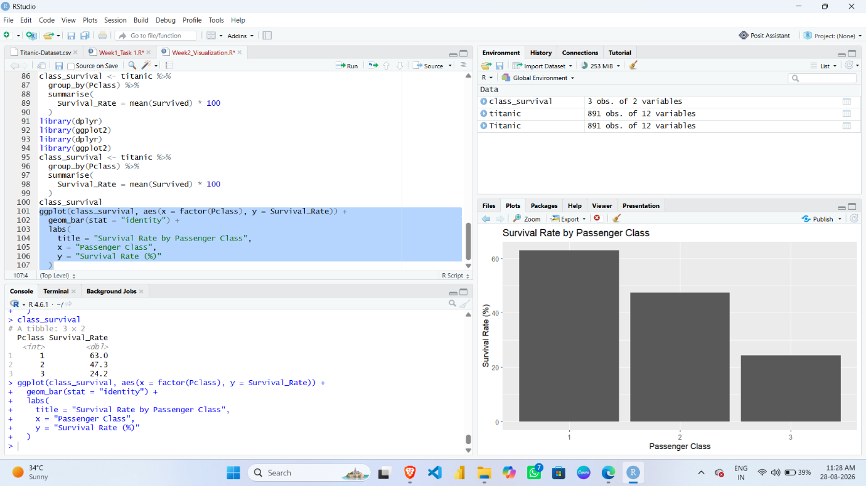

5.8 Survival Rate by Passenger Class
This bar chart shows the survival rate of passengers in each passenger class. The data was grouped according to Passenger Class, and the percentage of passengers who survived was calculated.
A bar chart was used because it provides a clear comparison of survival rates between the three passenger classes. The graph shows that survival patterns varied across different classes.
This visualization provides an important insight because it suggests that passenger class was associated with survival outcomes. Comparing percentages rather than only total survival counts makes the comparison more meaningful because the total number of passengers in each class was different
5.9 Average Fare by Age

R Code
age_data <- titanic %>%
group_by(Age) %>%
summarise(
Average_Fare = mean(Fare)
)

ggplot(age_data, aes(x = Age, y = Average_Fare)) +
geom_line() +
labs(
title = "Average Fare by Age",
x = "Age",
y = "Average Fare"
)

Graph Screenshot
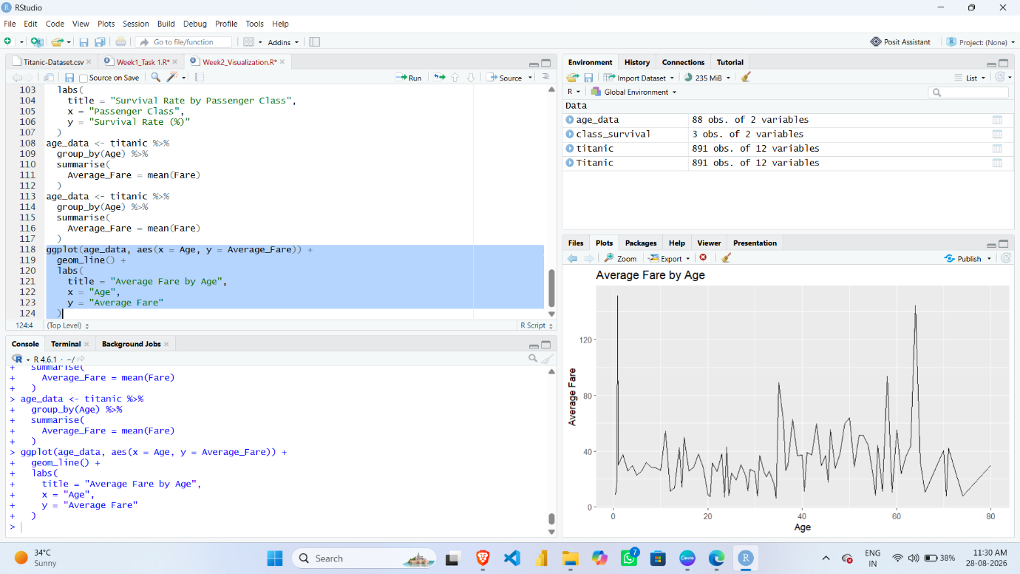

5.9 Average Fare by Age
This line chart shows the variation in average ticket fare across different passenger ages. The data was grouped by Age, and the average Fare was calculated for each age value.
A line chart was selected because it is useful for showing changes and variations across an ordered numerical variable. The graph helps observe how the average fare changes across different age values.
The visualization does not necessarily indicate that age directly determines ticket fare. Instead, it provides a visual representation of how the average fare varied among different age groups. Other factors, such as passenger class and ticket category, may also influence the fare.

5.10 Survival Rate by Gender

R Code
gender_survival <- titanic %>%
group_by(Sex) %>%
summarise(
Survival_Rate = mean(Survived) * 100
)

ggplot(gender_survival, aes(x = Sex, y = Survival_Rate)) +
geom_bar(stat = "identity") +
labs(
title = "Survival Rate by Gender",
x = "Gender",
y = "Survival Rate (%)"
)

Graph Screenshot
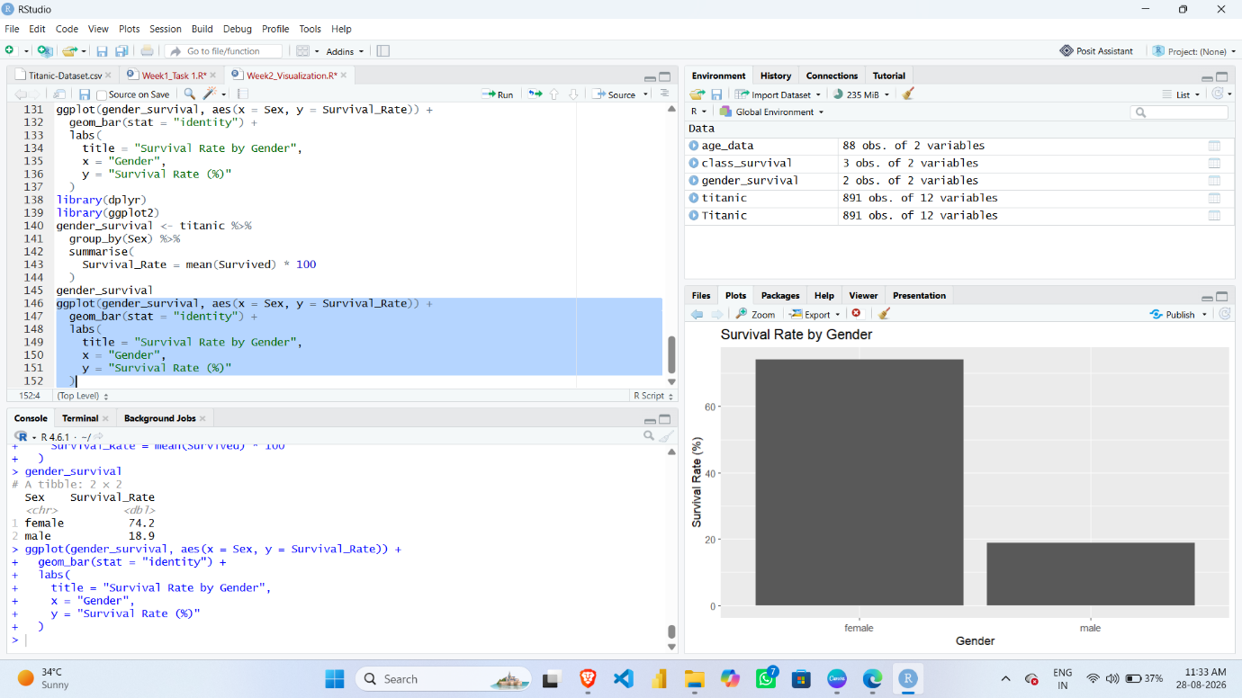

5.10 Survival Rate by Gender
This bar chart compares the survival rates of male and female passengers. The dataset was grouped by gender, and the percentage of passengers who survived was calculated for each group.
A percentage-based bar chart was selected because it allows the survival outcomes of the two gender groups to be compared clearly. The graph shows a noticeable difference between the survival rates of male and female passengers..

